Veloculture “Mark Strang Memorial “ Timetrial on the M13 course
Also comprising the GHS Regional Youth Qualifier on the M13s course
10th June 2023

First rider off 9.01am

Promoted for and on behalf of CTT under their rules & regulations.
This is a Northumberland & Durham Cycling Association BAR Event.

Event Secretary: Justine Norman
30 Robsons Way
NE65 0GA
Tel: 07725071072

Timekeepers: Ray Luckett
Peter & Frances Schultz
Sharon Dyson

Event HQ: Embleton Village Hall

- Riders should consider carrying a mobile phone and tool kit with them- please make note of the organizer mobile number to contact in case of a mechanical
- Please note you must wear a Helmet and have working front and rear lights

Event instructions

- Embleton Village Hall (post code NE66 3UP) is the HQ and will be open from 8am to sign on and collect numbers. – please sign off at the HQ afterwards.
- If you fail to sign out you will be recorded as a DNF on the results sheet.
- Sign in and sign out must be completed by the rider and no one else.
- Numbers are reusable- please return your numbers after competing.
- There will be some refreshments in the hall after the race
- Numbers should be clearly visible and placement adhere to CTT regulations
- Toilets will be available to use in the Hall.
- Embleton is a small village so please be respectful while parking/warming up in the village. Please do not use turbo trainers in residential areas. There is a small amount of parking at the Hall so parking will need to be around the village but please be respectful to residents when parking.
- For those on Road bikes please refer to the CTT guidance on permitted equipment
- Junior riders must bring or email the organiser a completed parental consent form
- All riders must adhere to CTT regulations at all times
- There is no prize money as this event is a charity event

Course M13:
Start just north of Embleton on the B1339 opposite the lay-by.
Proceed north on the B1339 to turn left on to the B1340 in the direction of Christon Bank. Proceed to the junction with the B1347 at Christon Bank.**** Turn left to continue south on the B1340 to the junction with the minor road near Hocketwell.
Bear left on to minor road and continue south to minor road on left near Littlehoughton. Turn left on to minor road and proceed east to the T-junction with the B1339. Turn left on to the B1339 and proceed north towards Embleton. Finish at the lay-by PRIOR to Embleton village. Please shout your number as you pass the finishing timekeeper.

****Please be aware that there are 2 traffic calming measures in Christon Bank- one as you ride into Christon Bank (you must give way to traffic) and one after you have turned left in Christon Bank (you have priority) . Please treat these traffic calming measures with respect. Marshals will be in the vicinity and any riding deemed to be unsafe will result in disqualification

Course M13s – GHS Youth Qualifier course

Please see the map on CTT for the M13s route. The course is approximately 8.4 miles long. The start is on the B1340 near the junction with the road that is signposted to Rock . At this turn there is an area where parents can park their cars and then the start is just further south on the B1340 at the next gateway on the left. The rest of the course is as the M13 above.
Please note parents must not follow their children in the car
Consent forms must be completed for all junior riders prior to racing
Front and back lights are compulsory and Helmets must be worn
Winners from all age groups will automatically be entered for the GHS National finals in September near Hull
Entrants to this event must be aged under 17 as of 31st August 2023 ( minimum age is 12 )

Safety Update:
Note that there have been two accidents in 3 years on this course, both on part of the course highlighted above in red. This is a fast downhill section with a couple of tight corners that may have gravel at the very edges. If you have the opportunity prior to the race, please check this section of the course. Please ride with care and adapt speed to the road conditions.

Please do not warm up around the start area or on the course

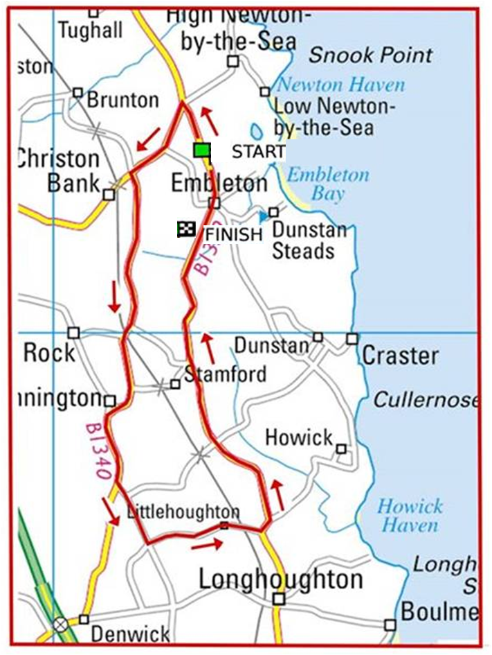
Start of M13s course

Safety Notes:
- Vehicles of competitors / officials / marshals / helpers to be parked safely and without hindrance to other road users.
- Take extra care at road junctions.
- No U-turns to be made in the vicinity of the timekeeper.
- No pre-race warming up on course.
- Care by riders - do not cross the white line on left hand turns. Crossing the white lines may lead to a DQ
- Care by riders – extra care in built up areas.
- No dismounting by riders in finishing area.
- Extra care in Christon bank re traffic calming- as previously mentioned

If you find that you can no longer ride, please contact
Justine Norman
Justine.norman99@gmail.com

